Research Project Progress Report Week [9] – SIT723

|  |  |
| --- | --- |
| **Student Name:** | Satvik Sharma |
| **Supervisors’ Names:** | Prof. Maia Angelova |
| **Project Title:** | Financial Time Series Analysis with Machine Learning |
| **SIT723 Target Grade:** | Distinction  I believe I have completed the tasks according to the deadline I chose. I have completed the literature review and have started working on the Project design. |
| **Overleaf Project Link:** | <https://www.overleaf.com/read/frvfvmnnrstb> |
| **Project Folder Link:** | <https://deakin365.sharepoint.com/:f:/r/sites/SIT723-FinancialTimeSeriesAnalysiswithMachineLearning/Shared%20Documents/General/Satvik%20Sharma(218595095)?csf=1&web=1&e=laxNjw> |
| **Worklog:** | 242 hours  <https://deakin365.sharepoint.com/:x:/r/sites/SIT723-FinancialTimeSeriesAnalysiswithMachineLearning/Shared%20Documents/General/Satvik%20Sharma(218595095)/Worklog.xlsx?d=w2cfbd3ab588d42f58966474ef14f85c2&csf=1&web=1&e=2nMoH6> |
| **Project Plan** | |
| **Summary of the work planned with your supervisor:** | In the first four weeks, the first and foremost task was to complete the Literature Review. The advantage of doing the literature review was to understand what kind of machine learning models are used by the people by the researchers.  Next step was to create a research design and start with the machine learning project. Choose a machine learning model and evaluate stocks with the help of the chosen machine learning model. |
| **Summary of the work done:** | The literature review has been completed and a number of papers have been reviewed. The next part, that is, completing of the research design has been started along with the creation of the artefact. The machine learning model will be created in the Jupyter notebook. The data pre-processing has been started and the machine learning model will be made. Research on different machine learning algorithms is still in process and the best machine learning model(s) will be chosen for the project.  For this task I chose a dataset of 10 years of Nifty-50 stock data and worked on the return value of the stock. The return value for me is defined as the previous date closing value subtracting from closing value divided by previous closing value. The models which I chose to work on were all statistical models and belonged from the ARIMA family. throughout the next five weeks I worked on developing them and correcting them.  I have also worked out on evaluating the models using the mean absolute error, R2, and root mean squared error. The comparison table for different algorithms implemented is given below. The stock chosen for this table is HDFC, which is one of the top stocks in NIFTY-50. The graphs of the predictions are given below   |  |  |  |  | | --- | --- | --- | --- | |  | *MAE* | *R2* | *RMSE* | | *AR* | *1.297* | *-0.033* | *1.738* | | *ARIMA* | *1.299* | *-0.036* | *1.7412* | | *ARIMAX* | *0.415* | *0.89* | *0.589* | | *SARIMA* | *1.307* | *-0.05* | *1.752* | | *SARIMAX* | *0.812* | *0.814* | *1.18* | | *HWES* | *1.309* | *-0.03* | *1.74* | |
| **Next steps:** | The next step is to finish up the model and start with the research article completion on the Overleaf and submit with the proper forecasting for at least one year or six months depending on how accurate the model is. Furthermore, the next step could be developing the hybrid machine learning model in the next iteration of the project, that is in the second part of the project. Including that, what I really want to do is like create portfolios for different people based on their duration they want to invest their money. |
| **Overall project progress:** | The project is going on with the good speed and with the current progress the project will be completed on time. |

# Reflection against Assessment Rubric

Add comments and evidence against your target grade for each criterion in the assessment rubric. You should also provide evidence (relevant to your target grade) on how you meet all the relevant criteria for that grade based on your progress so far.

*In case you have not started work on a specific criterion, e.g., research evaluation, leave it blank.*

|  |  |
| --- | --- |
| **Your reflection on work done so far against the assessment rubric criteria** | |
| **Literature Review** | High Distinction |
| **Technical & Academic Writing** | High Distinction |
| **Research Design** | Credit |
| **Project Management** | High Distinction |
| **Artefact Development** | Distinction |
| **Research Evaluation** | Credit |
| **Research Dissemination** | Credit |
| **OVERALL** | Distinction |

## Additional Evidence

Add any evidence that supports your case for your target grade. For example, screenshot of git commits log, screenshot of your cloud storage folder, progress in your research report or artefact development, or a visual chart to illustrate project progress so far.

*This is your research project, and you need to demonstrate (****with evidence****) how you meet criteria for a certain grade. Make this project report easy to read and help anyone reading this report assess, with least effort, the progress you have made.*

***Trello Board***

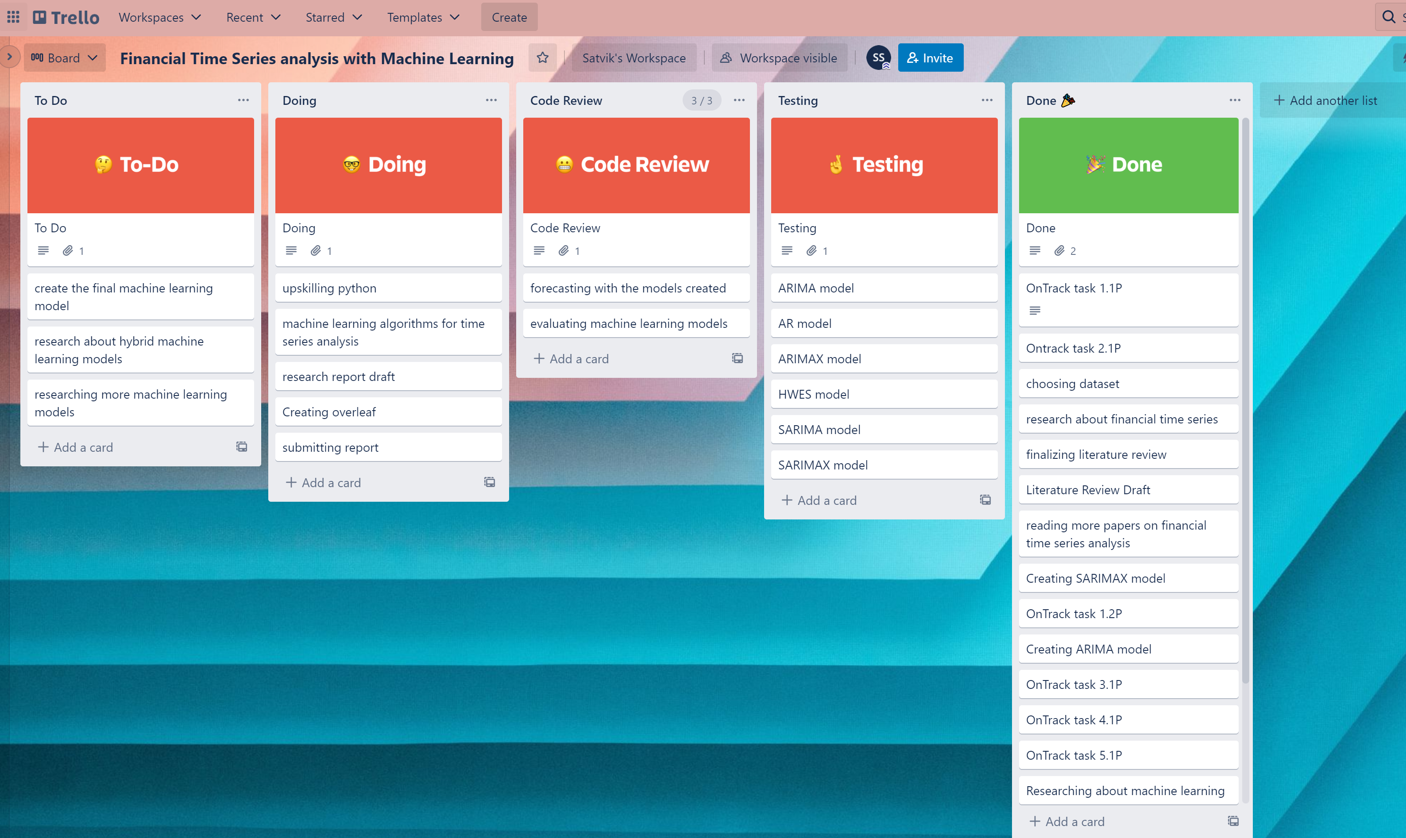

***GitHub***

[***https://github.com/satviksharmase/Financial-Time-Series-Analysis-with-Machine-Learning***](https://github.com/satviksharmase/Financial-Time-Series-Analysis-with-Machine-Learning)

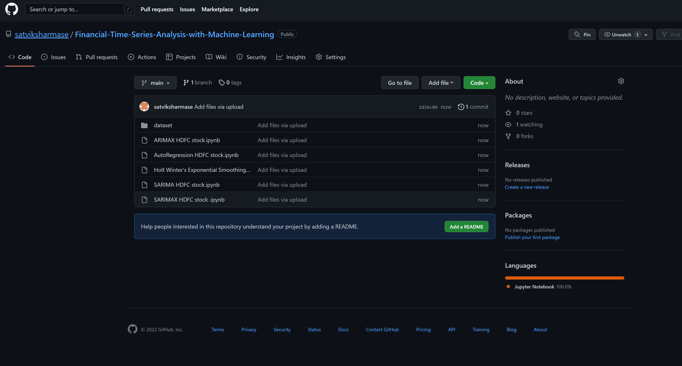

***Literature review***

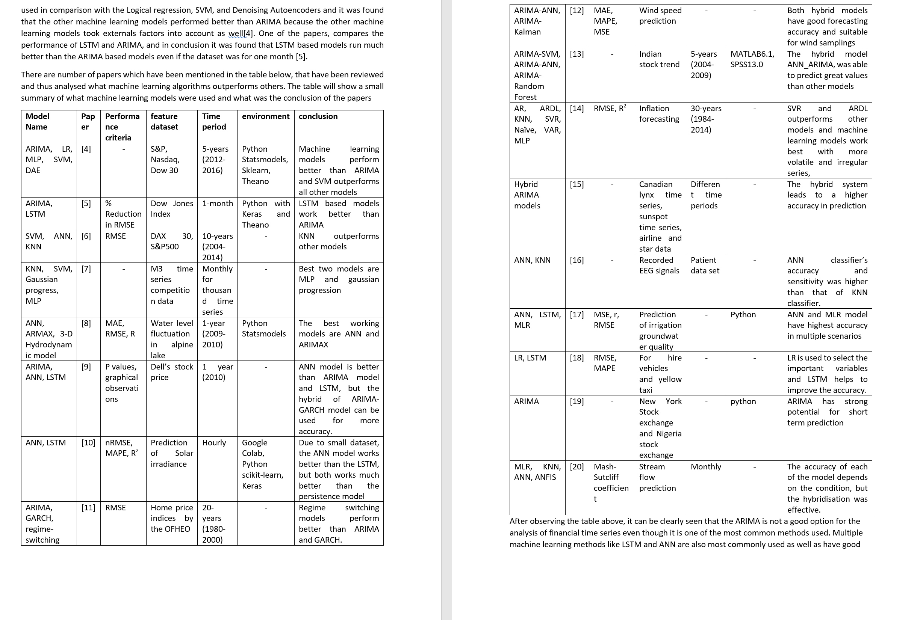

***Project folder***

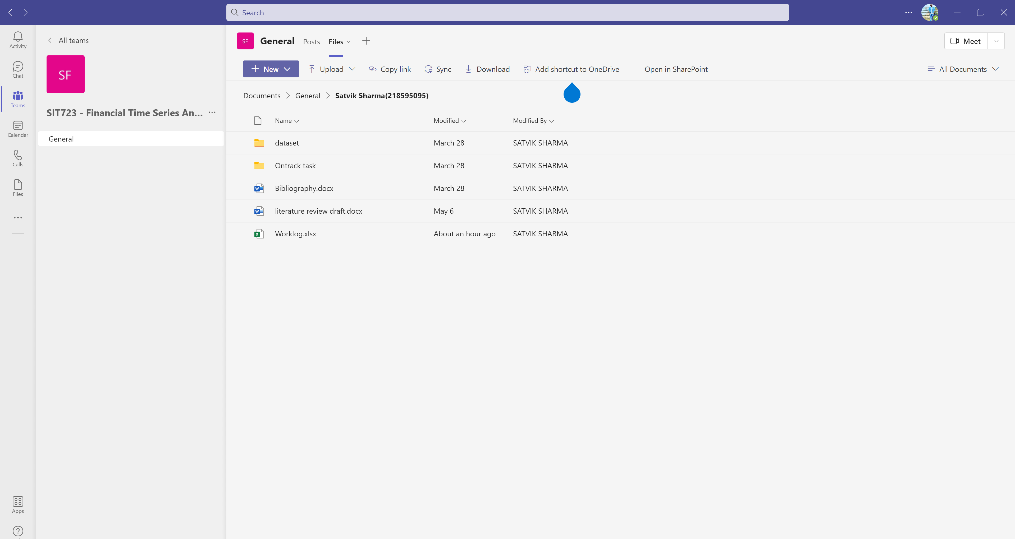

***Worklog***

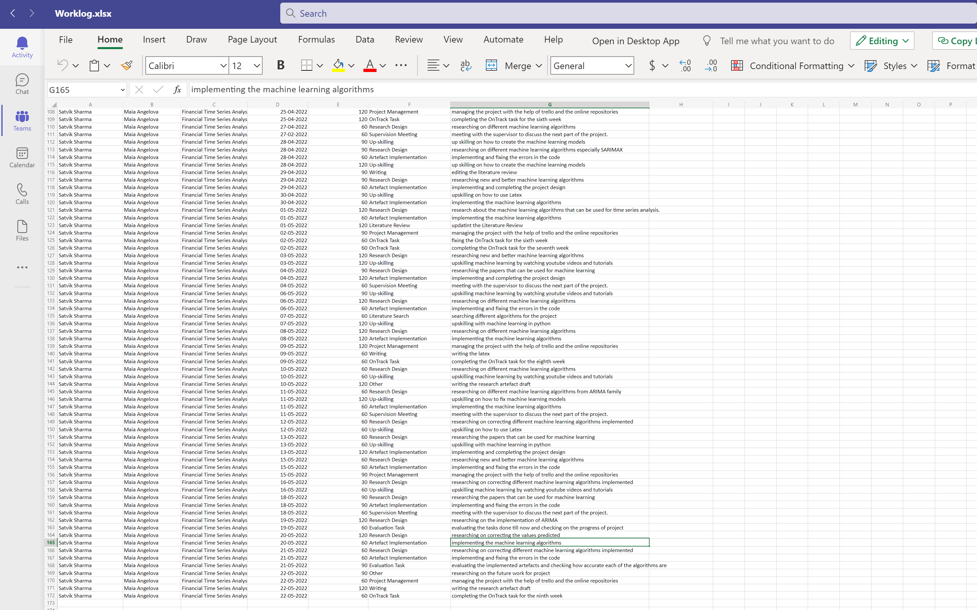

***Machine learning evaluation table***

